 | G H Raisoni College of Engineering and Management  Wagholi, Pune  Department of Artificial Intelligence  (An Autonomous Institute Affiliated to SPPU, Pune) | 

- INTRODUCTION
Abstract –
In this paper, the PDF to Audio Converter is proposed. It provides an alternative way to access the books and any pdf file for lazy, readers, and others. Using this PDF to Audio Converter the user will be able to listen to his\her favorite PDF and can do their daily routine. The application can be used to read any PDF which has[1].
The following application can be used to convert text from PDF to audio using PYSimpleGUI and python files, functions, and definitions. The main packages used in this audiobook converter are pytesseract and PyGame libraries. gTTs is a python library used for text to speech conversions. This is the reason which helps the machine to speak to us. Pytesseract extracts the text from the PDF. This is a python library built as a PDF toolkit. To overcome the(issues) the project PDF to Audio Converter has been developed to extract data from the pdf selected by the user, and to extract the data from the pdf, convert it to audio format to read out loud.
PDF to Audio Converter is a GUI application containing buttons for voice conversions, Destination Language and also has a feature to open a pdf, it will display the pdf while reading.
Index Terms - Python, pytesseract and PyMuPDF, Text to Speech, Converter, PYSimpleGUI .
Text-to-speech and related read audio tools are being widely implemented in an attempt to assist students’ reading comprehension skills.PDF to the audio system is a screen reader application designed and constructed for an effective audio communication system. PDFs were designed to present and exchange documents reliably, PDFs are an open standard document format used globally, maintained by the International Organization for Standardization (ISO).
document format is one of the most convenient methods for electronic communication, and also for the exchange of information. Hence, there is a need to make it more accessible to readers on-screen through audio. PDF documents are designed and structured to contain links and buttons, form fields, audio or sounds, video, and business logic. The PDF to the audio system will power text on screens to read aloud (speak) with support for many languages . The PDF to Audio Converter project provides an alternative to access the PDF books for the blind, lazy, readers, and others. Using this PDF to Audio Converter the user will be able to listen to his\her favorite PDF and can do their daily routine. The following application can be used to convert text from PDF to audio using Python predefined libraries like pytesseract and PyMuPDF and also using some pygame files.
In the current busy routine people do not have time to take a book and spend time reading it, instead, everyone needs alternative access to read the content. If a person is traveling, he\she cannot read a book, instead of reading, they can listen to it. Reading stories or essays or any text can be arduous however an audiobook would make the task easy, by reading the text. However, an audio reading of the text is convenient and does not require much concentration as reading requires. When a person tends to read a book, it requires to invest his/her time in reading. Whereas the audiobook makes the task easy, and the user can perform their own task as well as listening to the audio. In this project, we have implemented a simple PDF to audio converter using python.
When we compare with the current features present in a normal audiobook converter, they convert PDF texts (or images) into speech, and they have volume controls with single voice conversion (either male or female). Only a single choice is given to the user in case of voice modification. They provide the play and pause options. The speed of voice is always fixed.
While seeing the Audiobook converter which we have built, it converts the PDF text (or images) into speech with differences in the same PDF document. Voice conversions are possible. The rate of speed of voices can also be changed (fast, normal, and slow) for better clarifications.
The user can also save, and modify the PDF document, while the audio of the converted PDF is running in the background. This exclusive feature reduces the time consumption of writing notes and reduces paper consumption.
We can also open the required PDF or any other PDF, while the audio is playing in the background.
The objective of our project is:
In the current generation students, researchers, authors don’t find time to read a book on an electronic device as that might strain their eyes and might face other issues (headache, itchiness in the eye). So, to overcome those problems we have designed an application that extracts the text from the selected PDF and reads it out to the user.
Background Study of the project is:
Adobe Systems made the PDF specification available free of charge in 1993. In the early years PDF was popular mainly in desktop publishing workflows and competed with a variety of formats such as Common Ground Digital Paper, Farallon Replica, and even Adobe's own PostScript format.
PDF was a proprietary format controlled by Adobe until it was released as an open standard on July 1, 2008 and published by the International Organization for Standardization as ISO 32000-1:2008, at which time control of the specification passed to an ISO Committee of volunteer industry experts. In 2008, Adobe published a Public Patent License to ISO 32000-1 granting royalty-free rights for all patents owned by Adobe that are necessary to make, use, sell, and distribute PDF-compliant implementations [3].
Audiobooks allow students to hear explicit sounds of letters and letter patterns that form words. Audiobooks also help students engage in text and gain exposure to more words, ultimately improving vocabulary, comprehension, and critical thinking skills [4].
In this project, we present a simple way to combine different Python libraries for creating an Audiobook that takes a PDF file path as input and reads the text in the PDF file to the user via audio. Python programming language was used to create this project.
This code will ask the user to select any pdf file and will count the pages in the pdf and extract data from the pdf page by page and read the extracted data to the user.
  - Evolution

    - Image Processing

2.LITERATURE SURVEY

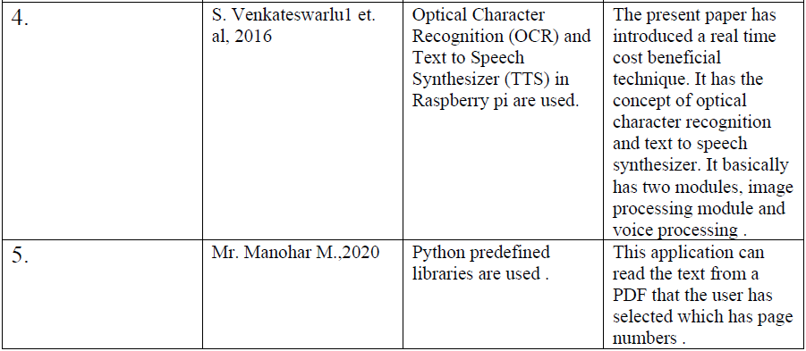
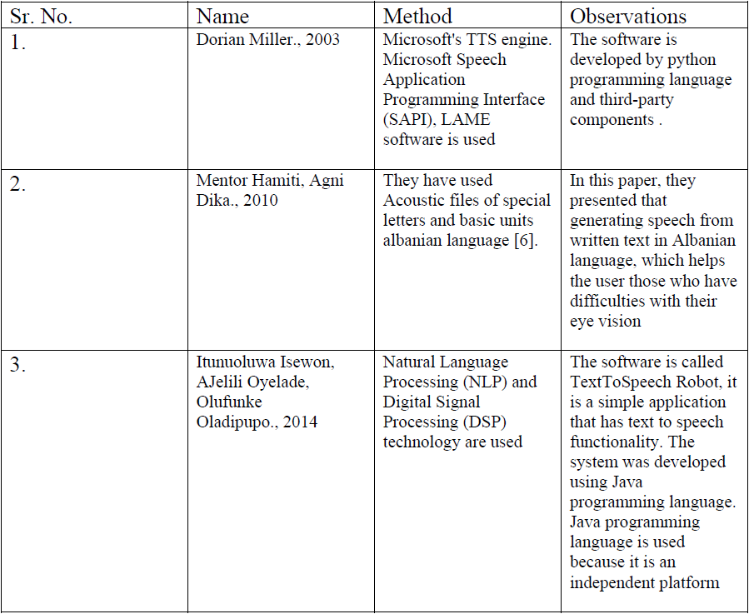

This section is an overview of different computer solutions to provide audiotexts. Each solution has its unique navigation techniques between pages, sections, paragraphs etc. and its special features.
Books on tape is the oldest form of audio books started in 1970’s and continued to be provided by the Recordings for Blind and Dyslexic (RFBD) [1]. Readings of a book are stored on tapes. A special tape recorder is used to listen to the four sides of the tape; besides the two sides of a normal tape, two more sides are available by reversing the play
direction. The tape recorder also provides a dial to vary the playback speed; listeners familiar with the text or just skimming it can increase the tape speed. The inconvenience of using books on tape is that one book requires a large volume of tapes and it is tedious to flip and rewind/fast-forward the tape to find the desired section. However, to assist
with the navigation, beeps are used while fast-forwarding or rewinding to indicate page transitions. The listener finds relevant information with an index card accompanying the tapes, which indicates which tape, side and direction pages are on. Digital talking book (DTB) is a standard for audio books developed by the Digital Accessible Information System (DASIY) consortium and standardized in 2002 by the National Information Standards Organization (NISO). The DTB standard describes how multimedia information, such as audio files, text files and images, are composed to create
an audio book. The standard is flexible and combines variable amounts of audio and corresponding text, which enables text searches. Having complete audio and text is not needed, for example, in a dictionary, which might have the complete text and audio only for pronunciations. A DTB viewer program can use the text to display word definitions to
a Braille display. Also with a DTB viewer the reader can efficiently navigate between or within sections, because of the hierarchical document structure defined by the DTB standard. Blind people rely on screen reader software, such as JAWS, to use a PC and read electronic documents. The screen reader reads all text that appears on a screen. Navigating the PC desktop and applications is possible with a series of keystrokes. Electronic documents, such as web pages, are also navigated with keystrokes, which enable moving between pages, lines, and words. The navigation, however, is limited Dorian Miller * Assistive technology* 4/26/2003 because there are no direct keystrokes to find the beginning of sections, paragraphs, or sentences. The original motivation for this project was to provide access to PDF files, which until recently were not accessible with screen readers. In the meanwhile, however, Adobe has released Acrobat Reader 5.1, the standard PDF viewer, with screen reader accessibility. Regardless of Abode’s recent development, the solution to listening to audiotexts on anMP3 player provides a unique and convenient access to text material.

- EXISTING SYSTEM

The Blind and Dyslexic people would find it difficult to read, to support those people different computer solutions have provided many alternative ways to convert text to audio. . Readings of a book are stored on tapes. consortium and standardized in 2002 by the National Information Standards Organization (NISO). The DTB standard describes how multimedia information, such as audio files, text files and images, are composed to create an audio book. Many other solutions are to convert PDF files to MP3 players using third party applications or web applications.
ISSUES
In this section we are discussing the issues faced in the above section, they are .Readings of a book are stored on tapes, the inconvenience of using books on tape is that one book requires a large volume of tapes and it is tedious to flip and rewind/fast-forward the tape to find the desired section.

- PROPOSED SYSTEM

In this current busy routine people do not find time to read a book, or to convert the PDF file into MP3 player using third party applications or web application. In this system I am developing an application using python to convert the PDF file into audio format and read out to the user. The application is more used friendly as it not requires any audio file or MP3 player. The user will have to select the PDF file which user wants to listen.
In this system, we are developing a GUI application using python to convert the PDF file into audio format and read it out to the user. The application is more user-friendly as it does not require any audio file or MP3 player. The user will have to select the PDF file which the user wants to listen to. The problem Statement of this project is: To create a PDF to Audiobook Converter using different Tkinter and python files, functions, and definitions. The main packages used in this audiobook converter are PyMuPDf,Pytesseract, fitz and Pygame. PyMuPDF is a Python binding for MuPDF – a lightweight PDF, XPS, and E-book viewer, renderer, and toolkit, which is maintained and developed by Artifex Software, Inc MuPDF can access files in PDF, XPS, OpenXPS, CBZ, EPUB and FB2 (e-books) formats, and it is known for its top performance and high rendering quality. MuPDF stands out among all similar products for its top rendering capability and unsurpassed processing speed. At the same time, its “light weight” makes it an excellent choice for platforms where resources are typically limited, like smartphones.
Python-tesseract is a wrapper for Google’s Tesseract-OCR Engine. It is also useful as a stand-alone invocation script to tesseract, as it can read all image types supported by the Pillow and Leptonica imaging libraries, including jpeg, png, gif, bmp, tiff, and others. Additionally, if used as a script, Python-tesseract will print the recognized text instead of writing it to a file.
The pygame library is an open-source module for the Python programming language specifically intended to help you make games and other multimedia applications. Built on top of the highly portable SDL (Simple DirectMedia Layer) development library, pygame can run across many platforms and operating systems. By using the pygame module, you can control the logic and graphics of your games without worrying about the backend complexities required for working with video and audio.
Googletrans is a free and unlimited python library that implemented Google Translate API. This uses the Google Translate Ajax API to make calls to such methods as detect and translate. PDF to Audio Converter is a GUI application containing play, pause(buttons), and label to display text which allows the user to select the PDF files and the user has to click on the play button in order to extract text from the PDF file and will read the text. The application has been developed in a way that until the speaker reads out the extracted text the player cannot be paused. The GUI is also provided with a label to display the text, the text will only be displayed only after reading the extracted text. With PDF being the most used document format globally, there is a need to convert the text in PDF formats into Audio signals. These can be utilized for various purposes, e.g., in the educational system, car navigation, announcements in railway stations, response services in telecommunications, and email reading. Furthermore, people with vision disabilities cannot view or read PDF files and this is a major setback. This research addresses the problems in converting PDF text into speech. One is how to improve the naturalness of synthetic speech in PDF-based text into an Audio system.

The Workflow of the project is:
• In this PDF to Audio Converter the user needs to select any PDF file from the desired location by pressing the open pdf.
• After selecting the PDF file, we have to select the Range of pages we want to convert in the audio.
• After selecting the Range, we have to select in which language we want the pdf to be converted .
• After pressing enter key ,Program will display the desired output.
• To exit the program, we press the cancel button. The objective of our project is: In the current generation students, researchers, authors don’t find time to read a book on an electronic device as that might strain their eyes and might face other issues (headache, itchiness in the eye).
So, to overcome those problems we have designed an application that extracts the text from the selected PDF and reads it out to the user. Audiobooks allow students to hear explicit sounds of letters and letter patterns that form words. Audiobooks also help students engage in text and gain exposure to more words, ultimately improving vocabulary, comprehension, and critical thinking skills. In this project, we present a simple way to combine different Python libraries for creating an Audiobook that takes a PDF file path as input and reads the text in the PDF file to the user via audio. Python programming language was used to create this project

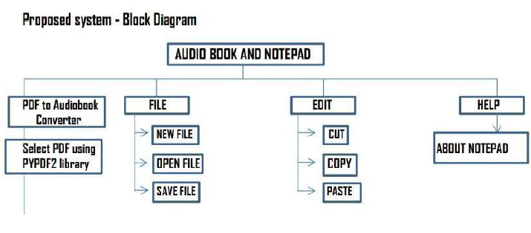

- PROBLEM STATEMENT & ARCHITECTURE

The above section (related work) we have discussed the way audio book was used. This section(issues) describes the drawback of the older versions of audio book. To overcome the(issues) the project PDF to Audio Converter has been developed to extract data from the pdf selected by the user, and to extract the data from the pdf, convert it to audio format to read out loud with language Translation.

ARCHITECTURE

PDF to Audio Converter is a GUI application contains play, pause(buttons) and label to display text which allows the user to select the PDF files and the user has to click on the play button in order to extract text from PDF file and will read the text. The application has been developed in a way that the until the speaker read’s out the extracted text the player cannot be paused. The GUI is also, provided with a label to display the text, the text will only be displayed only after reading the extracted text.

- WORK FLOW

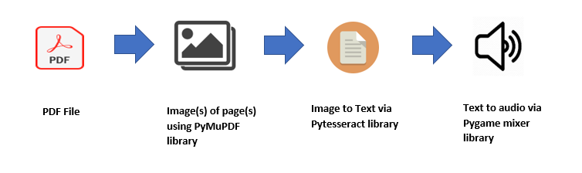

- ALGORITHM

1.Take the PDF file and convert each page into image using PyMuPDF library.
2.Take the image(s) and scan the text in the image using Pytesseract OCR library.
3.Use Google Text to Speech (gTTS) library to convert text to audio file.
4.Get the Pygame mixer to play the audio file loud.
5.Convert text in selected language and create a .txt file for storing the converted text.

- FLOWCHART
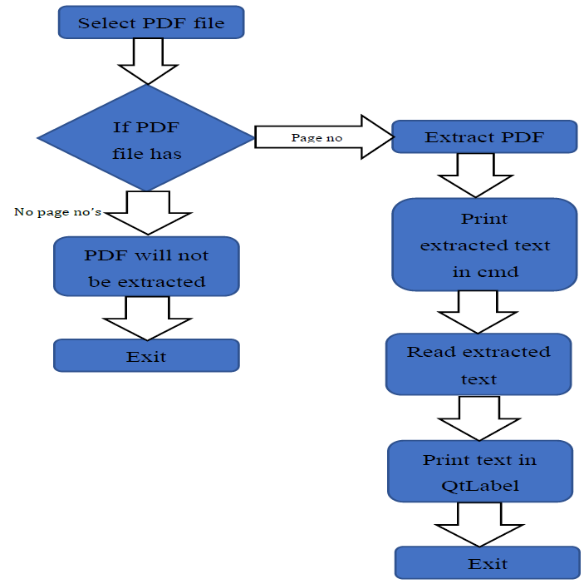

- RESULTS

Screenshot Of PDF to audio converter interface

TRANSLATED TEXT

AUDIO FILE GENERATED

- ADVANTAGES

- It avoids eye-strain from too much reading.
- It helps seniors or those having vision problems.
- It can help in reading large paragraphs and offers range of different languages.

- DISADVANTAGES

- Pronunciation analysis from written text is a major concern.
- It is difficult to build a perfect system.
- Filtering background noise is a task which can even be difficult for humans to accomplish

- CONCLUSION AND FUTURE WORK

- It was seen that this code performs really well in reading straightforward PDF text files.
- Should enable users to select the desired PDF and convert it to audio and display text in, so the user can understand that particular text has been read.
- Should enable students with reading disabilities.
- The success of this research project is significant given the broad use of audiobooks in literacy and library programs across the United States.
- Teachers and school librarians may also use these findings as a rationale for adding audiobooks to the list of reading strategies used successfully with struggling readers.
- We are interested in future research on the use of audiobooks with struggling readers who are younger and older than those who participated in the study and on audiobook usage with English Language Learners [10].
- At this point, the code does not have a stop feature, I intend to add those and do more interesting things with the application of Machine Learning in the audiobook. With the help of machine learning, we can add the features that will recognize the voice of the user and implement the function as the user wants [10]. This feature will help mostly for the disabled users like the blind, handicap.

- REFERENCES

- AJINKYA DOMALE; BHIMSEN PADALKAR; RAJ PAREKH; M.A. JOSHI PRINTED BOOK TO AUDIO BOOK CONVERTER FOR VISUALLY IMPAIRED https://ieeexplore.ieee.org/document/6757125
- • Bernard Conan Pobiak-ADJUSTABLE ACCESS ELECTRONIC BOOKS, The Reader Project of Washington, D.C., 1992 IEEE
- • R. M. K. Sinha, "A Syntactic pattern analysis system and its application to Devanagari script recognitio," Ph.D. Thesis, Dept. Elect. Eng., Indian Institute of Technology, Kanpur, India, 1973.
- • R. M. K. Sinha and H. Mahabala, "Machine recognition of Devanagari script" IEEE Trans. Syst. Man Cybern., vol. 9, no. 8, pp. 435-441, Aug.1979.
- • S. Palit and B. B. Chaudhuri, "A feature-based scheme for the machine recognition of printed Devanagari script" in Pattern Recognition, Image Processing and Computer Vision, P. P. Das and B. N. Chatterjee, Eds. New Delhi, India: Narosa Publishing House, 1995, pp. 163-168.
- • P. V. S. Rao and R. B. Thosar, "A programming system for studies in speech synthesis," IEEE Trans. Acoust., Speech and Signal Processing, vol. 22, no. 3, pp. 217-225, 1974.
- • B. Yegnanarayana, S. Rajendran, V. R. Ramachandran, and A. S. Madhukumar, "Significance of knowledge sources for a text-tospeech system for Indian languages," Sadhana, pp. 147-169,1994
- • S. S. Agrawal, "Synthesizing Hindi speech using Klsyn and Hlsyn for natural sounding," in Workshop on Spoken Language Processing, TIFR, Mumbai, 2003.
- • X. A. Furtado and A. Sen, "Synthesis of unlimited speech in Indian languages using formant-based rules," Sadhana, vol. 21, no. 3, pp. 345-362, 1996.
- • Kishore Prahallad, E.Naresh Kumar, Venkatesh Keri, S.Rajendran, Alan W Black," The IIIT-H Indic Speech Databases
- • Jan Mennens "Optical recognition of Braille writing", IEEE 1993. pp 428-431.
- • Rajamani M. Kulkarni; Preetam R. Kalburgimath An Intelligent Text Reader based on Python An Intelligent Text Reader based on Python | IEEE Conference Publication | IEEE Xplore
- • Design and Implementation of Text To Speech Conversion for Visually Impaired People Itunuoluwa Isewon*, Jelili Oyelade, Olufunke Oladipupo Design and Implementation of Text To Speech Conversion for Visually Impaired People (core.ac.uk)
  - • Chithra Selvaraj, Bhalaji Natarajan Enhanced portable text to speech converter for visually impaired. o (PDF) Enhanced portable text to speech converter for visually impaired (researchgate.net)

